NMM-112
DAY 1 TAKE HOME QUIZ

- The basic types of changes at a facility that could constitute a transaction are:

  - movements of material between programs within a facility
  - physical movements of materials between facilities
  - physical security within a facility
  - on-site activity due to production, burnup, etc.
  - A, B, and D
- There are currently three enrichment facilities in the U.S. who report to NMMSS.

  - TRUE
  - FALSE
- The NMMSS community consists of the DOE/NNSA Complex as well as various

domestic and international programs.
  - TRUE
  - FALSE
- The following is not considered NMMSS reference data.

  - import/export licenses
  - concise notes
  - DOE project number names
  - nuclear material reporting units
- The following is not considered source material.

  - natural uranium
  - thorium
  - depleted uranium
  - curium
- There are types of nuclear material other than special and source that may

be required by the NRC to be reported to NMMSS?
  - TRUE
  - FALSE
- A facility shall report each transaction correction to NMMSS within 10 working days

of each identified correction?
  - TRUE
  - FALSE
- The following is not a valid disposition RIS code?

  - Fourth character of RIS is "W"-Discard to pond or lagoon
  - Fourth character of RIS is "A"-Release to the atmosphere
  - Fourth character of RIS is "H"-Discard to holding area
  - Fourth character of RIS is "R"-Consumed in research
- Which RISs do not follow the naming convention for an NRC licensee?

  - ZAP
  - XTB
  - BET
  - YAW

- If nuclear material is being reported as received by a DOE/NNSA site, the owner code

for the material would always be "G".
  - TRUE
  - FALSE
- A DOE facility (LDA) made its fourth shipment to NRC facility (ZTB) on June 15, 2021. The shipment has DOE-owned material being transferred to non-DOE-owned inventory that initiates a loan/lease of DOE-owned material. The following information will be reported:
Shipping Weight: 300 kg
Element Weight: 100 g
Weight % Isotope: 4.9500
Isotope Weight: 5 g
Material Type: Enriched Uranium
Comp Code: 309
Number of Items: 1
Project: LDA – ABC909090B
ZTB received the shipment on July 4, 2021. Populate the identified fields for the receiver’s DOE/NRC Form 741 accepting shipper’s values.
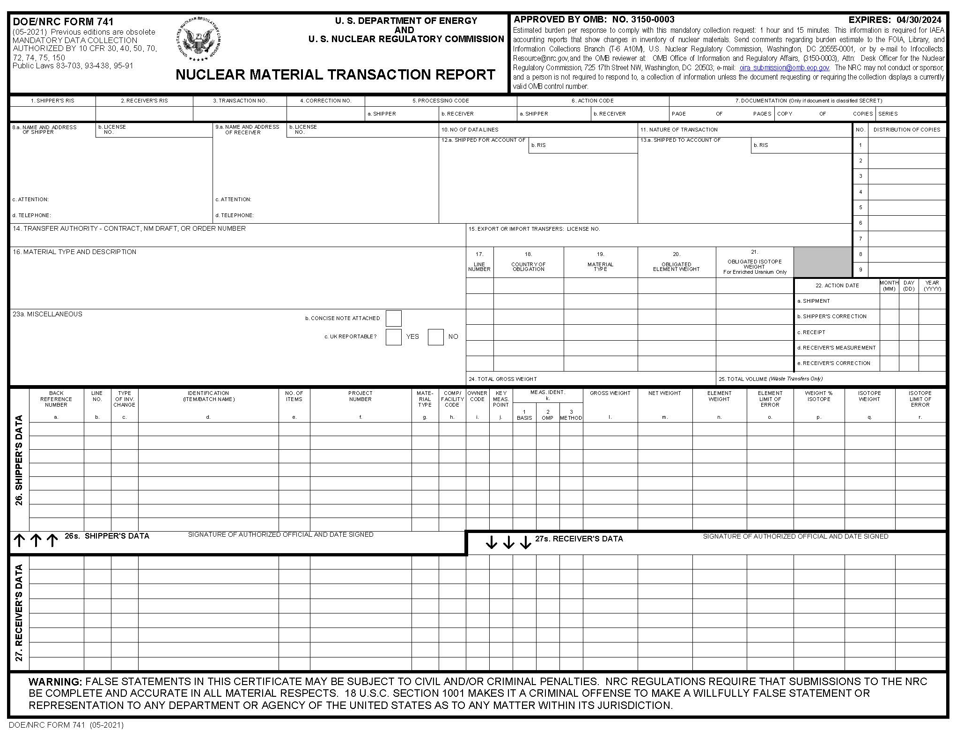

2.RECEIVER RIS
3.TRANSACTION NUMBER

10.NO. OF DATA LINES

24.TOTAL GROSS WEIGHT

27b.LINE NO.

27i.OWNER CODE
27h.COMP/ FACILITY CODE

27f.PROJECT NUMBER

27e.NO. OF ITEMS

27g.MATERIAL TYPE

27n.ELEMENT WEIGHT

27p.WEIGHT % ISOTOPE
27q.ISOTOPE WEIGHT

22.ACTION DATE
12a.SHIPPED FOR ACCOUNT OF

12b.SHIPPED TO ACCOUNT OF
11.NATURE OF TRANSACTION

6.ACTION CODE

5.PROCESSING CODE

1.SHIPPER RIS
- A Canadian facility (RDAY) made its shipment #1001 to DOE facility (FDD) on September 15, 2021. The shipment has non-DOE-owned material being transferred as a sale to DOE. All of the material in this shipment has Canadian foreign obligations. The following information will be reported:
Shipping Weight: 300 kg
Element Weight: 60 g
Weight % Isotope: 50.0000
Isotope Weight: 30 g
Material Type: Enriched Uranium
Comp Code: 309
Number of Items: 1
Project: FDD – ABC909090A
Batch ID: SN230
License: GEN-LIC
Populate the identified fields for the shipper’s DOE/NRC Form 741.
15. EXPORT OR IMPORT TRANSFERS LICENSE NO.

26q.ISOTOPE WEIGHT

26p.WEIGHT % ISOTOPE

26n.ELEMENT WEIGHT
26i.OWNER CODE

26h.COMP/ FACILITY CODE

26g.MATERIAL TYPE

26e.NO. OF ITEMS

26f.PROJECT NUMBER

26d.IDENTIFICATION (ITEM/BATCH NAME)

26b.LINE NO.
10.NO. OF DATA LINES

24.TOTAL GROSS WEIGHT

22.ACTION DATE
12a.SHIPPED FOR ACCOUNT OF

12b.SHIPPED TO ACCOUNT OF
11.NATURE OF TRANSACTION

6.ACTION CODE

5.PROCESSING CODE

3.TRANSACTION NUMBER

2.RECEIVER RIS

1.SHIPPER RIS

- Create a one-party transaction for facility XBC using today’s date and transaction sequence number in today’s date format (YYYYMMDD). All composition codes will be 309. Report the following onsite gains and losses of non-DOE-owned material:
- Degradation of enriched uranium (MT 20) to depleted uranium (MT 10) 0.2% assay
Helpful Hints
- Depleted uranium is reported in kilograms and enriched uranium is in grams.
- A reportable quantity is .5 or more for the reportable unit.
- For rounding, a negative adds material and a positive removes it.

  - Material type 20 14,709 grams element
- grams isotope
  - wt. percent isotope
- Production of Plutonium (MT 50) 170,923 grams element
108,499 grams isotope
  - wt. percent isotope
- Fission & Transmutation (MT 20) 536,060 grams element
26,535 grams isotope
  - wt. percent isotope
- Decay of Plutonium (MT 50) 7,914 grams element
7,914 grams isotope
  - wt. percent isotope
- Rounding (MT 20) Remove 2 gram of element
  - 00 wt. percent isotope
- Rounding (MT 50) Add 1 grams of isotope
4.0000 wt. percent isotope

26c.TYPE OF INV. CHANGE

26b.LINE NO.

27i.OWNER CODE
27h.COMP/ FACILITY CODE

27g.MATERIAL TYPE

27n.ELEMENT WEIGHT

27p.WEIGHT % ISOTOPE
27q.ISOTOPE WEIGHT

10.NO. OF DATA LINES
2.RECEIVER RIS
3.TRANSACTION NUMBER

22.ACTION DATE
6.ACTION CODE

5.PROCESSING CODE

1.SHIPPER RIS

- On September 15, 2021, facility FDD needs to make an adjustment to line #1 on the transaction series RDAY-FDD transaction #1001 (refer to take-home quiz question #12). The element weight should have been 50, the isotope weight should have been 20, and the Weight percent isotope should have been 40.0000. Populate the identified fields for the adjustment shipper’s imports DOE/NRC Form 741.

15. EXPORT OR IMPORT TRANSFERS LICENSE NO.

26e.NO. OF ITEMS

26f.PROJECT NUMBER

26d.IDENTIFICATION (ITEM/BATCH NAME)

26b.LINE NO.

26A.BACK REFERENCE NUMBER

26n.ELEMENT WEIGHT

26h.COMP/ FACILITY CODE

26g.MATERIAL TYPE

26i.OWNER CODE

26p.WEIGHT % ISOTOPE

26q.ISOTOPE WEIGHT

3.TRANSACTION NUMBER

2.RECEIVER RIS

1.SHIPPER RIS
4. CORRECTION NO.

5.PROCESSING CODE

6.ACTION CODE
11.NATURE OF TRANSACTION

10.NO. OF DATA LINES

24.TOTAL GROSS WEIGHT

22.ACTION DATE
12a.SHIPPED FOR ACCOUNT OF

12b.SHIPPED TO ACCOUNT OF

